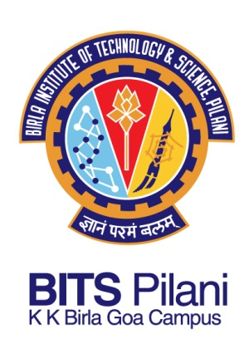
SANKEERTH BILLAKANTI

Phone: +91 9552435396
Email: sankeerth.bits@gmail.com
Date of Birth: 7 November 1991
Address: 12-11-444, 2nd Floor,
Warasiguda, Secunderabad,
Andhra Pradesh – 500061
Languages Known: English, Telugu and Hindi

Career Objective:
I have a strong passion for Programming and Digital Electronics, desire for challenges and enthusiasm for learning. My objective is to seek a career path which gives me good opportunity to apply my acquired knowledge and skills to positively nurture our world.

Educational Qualifications:
Year | Degree/Certificate | Institution | Marks obtained
2013 | B.E. (Hons.) Electronics and Instrumentation Engineering | BITS Pilani  KK Birla Goa Campus | 8.65 / 10
2009 | Intermediate, Board of Intermediate Education(BIE), Andhra Pradesh | Delta Junior College | 90.7%
2007 | Secondary School Certificate, Andhra Pradesh State Board | St. Andrews High School | 91.6%

Projects:
- Development of a tool to read and write into DisplayPort Configuration Data (DPCD) registers of a DisplayPort sink device at Intel India Technology Private Limited, Bangalore.

- Development of a tool to read the Panel Self Refresh (PSR) performance values i.e. Residency and Entry counter value at Intel India Technology Private Limited, Bangalore.

- Identification of Stem and Calyx in apple image candidate objects using Image processing algorithms in Matlab at Central Electronics Engineering Research Institute (CEERI), Chennai.

- Z-Scan studies of certain organic compounds. This project involved making a primitive photo detector, using NI-DAQ card and NI Labview to read voltage and fit the voltage curve to desired polynomial equations using Matlab.

- Design and Layout of one bit full adder with minimum delay in Cadence Virtuoso as a part of Analog and Digital VLSI design course.

Technical Skills:
- Programming Languages/Tools: C, Verilog, Assembly language (Intel 8086 in MASM611), PSPICE and Matlab.
- Designing Tools: Cadence Virtuoso, NI Labview, NI Multisim and AutoCAD.
Relevant Courses:
- Analog and digital VLSI design  - Digital electronics and computer organization  - Microelectronic circuits  - Electronic devices and integrated circuits  - Transducers and measurement systems | - Microprocessor programming and interfacing  - C programming  - Circuits and signals  - Embedded system design*  - Data communication networks*
*courses pursuing in the current semester

Achievements:
- Received Spontaneous Recognition award for Results Orientation at Intel Corporation.
- Received merit cum need scholarship in college for three years.

Extra-Curricular Activities:
- Played Basketball for hostel in Slam 2010, 2011 and 2012.
- Part of the team winning Champions trophy for Gully Cricket in Spree 2012
- Member of Department of Finance and asset management (DOFAM) and Department of Security.

